Contents

HTML and CSS HACKATHON 2

Overview 2

Objectives 2

Website Overview 2

Mock Ups 2

Home Page Mock Up - Large size screen and above 3

Schedule Mock Up - Large size screen and above 4

Sign Up - Large size screen and above 5

User Stories 6

HTML and CSS HACKATHON

Overview

In this Hackathon you will be presented with the requirements to create a website for QA Cinemas. The skills and knowledge needed have been covered in the course so far.

Objectives

To use the skills and knowledge gained so far to create a simple web site.

Website Overview

QA Cinemas has approached us to create a modern looking website promoting their cinemas. In the first iteration, they would like to be able to provide their customers with general information about their cinemas, schedule and opening hours and allow them to subscribe to receive some promotional materials.

Mock Ups

The business representatives have worked with our UI/UX team and they have created the following low fidelity mock-ups. They understand that their customers view their pages on different devices and want us to accommodate to this. The site will be split into three pages –

* home page with information about the Cinemas;
* a 'schedule' page displaying opening hours and movies showing this week;
* a 'signup' page to gather some information about the user.

The navigation between the pages should be easy and straightforward, with a navigation bar on top of each page.

Home Page Mock Up - Large size screen and above

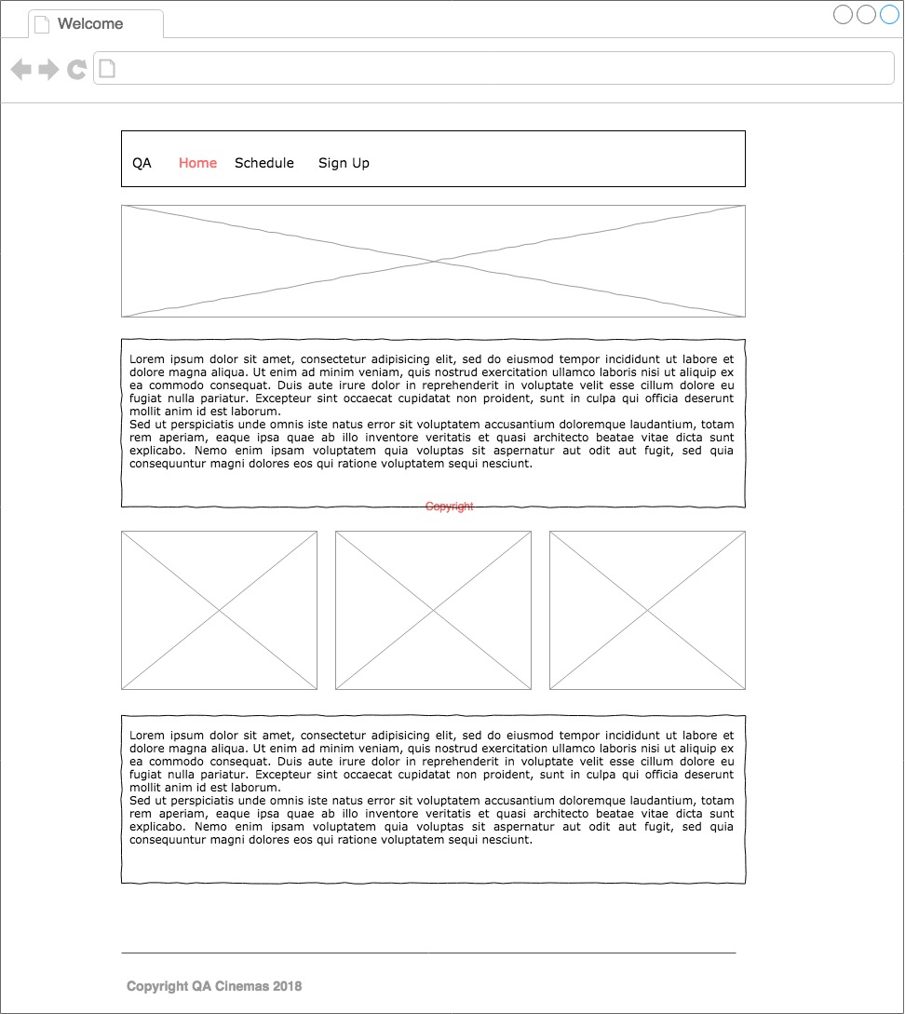

Schedule Mock Up - Large size screen and above

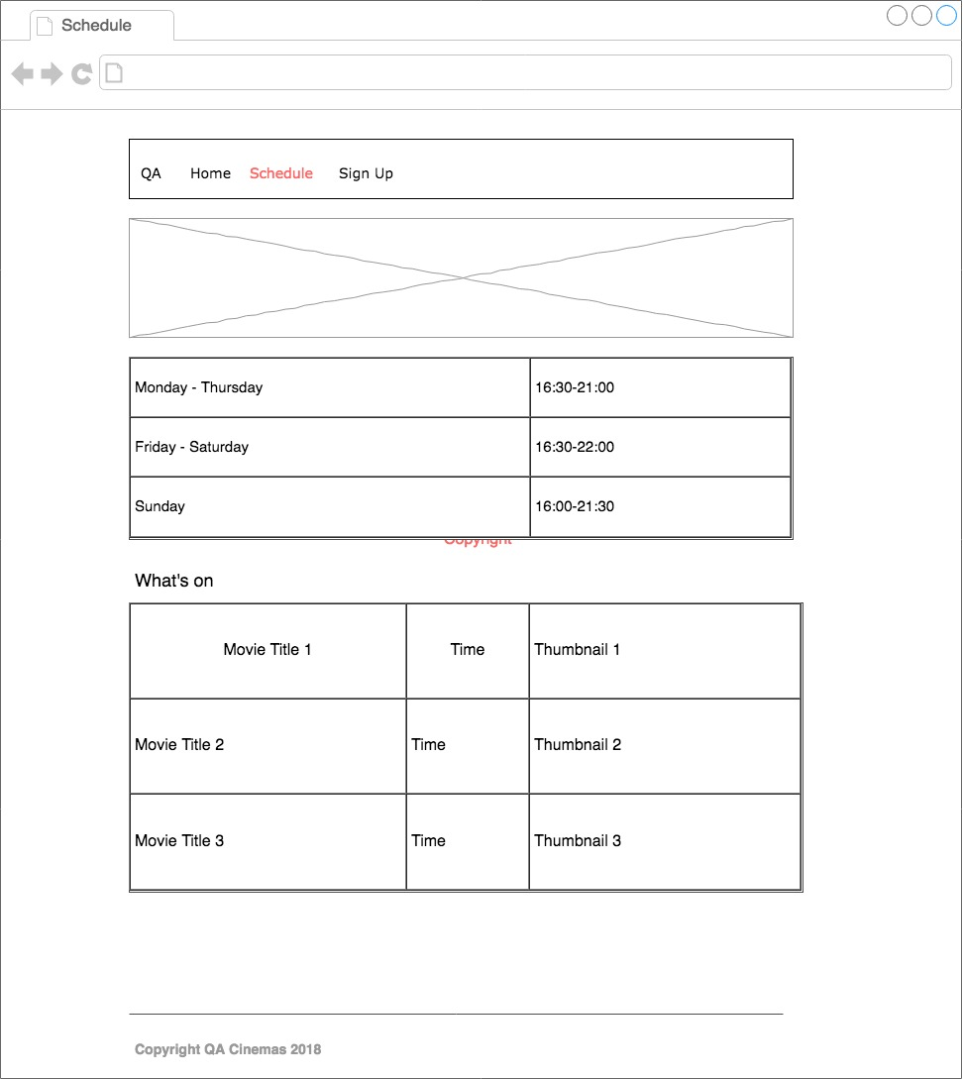

Sign Up - Large size screen and above

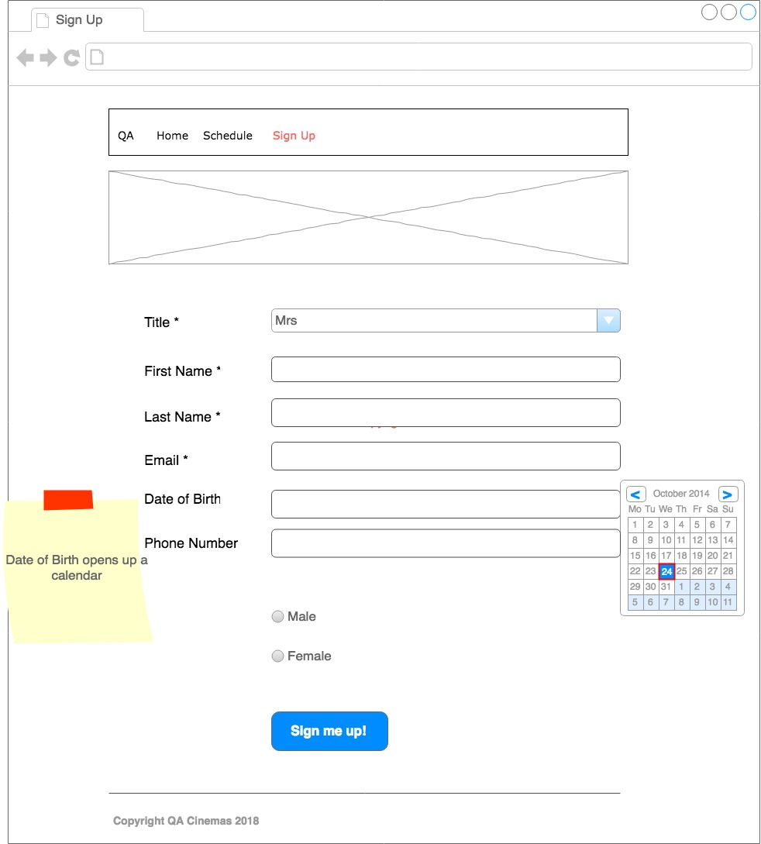

User Stories

The User Stories have been prioritized and ordered from 1 (most important) to 5 (least important):

1. As a User, I want to be presented with a home page, so that I can see some general information and pictures showing QA Cinemas.
2. As a User, I want to be able to see the opening hours of the cinema, so that I know when the cinema is open.
3. As a User, I want to be able to see the movie schedule for this week, so that I know what is on and at what time.
4. As a User, I want to be able to subscribe to the website using a form, so that I can receive the latest promotions and information.
5. As a User, I want to be able to access the website on any device, so that I can access the information I need on the device of my choice.